
User Guide

Introduction
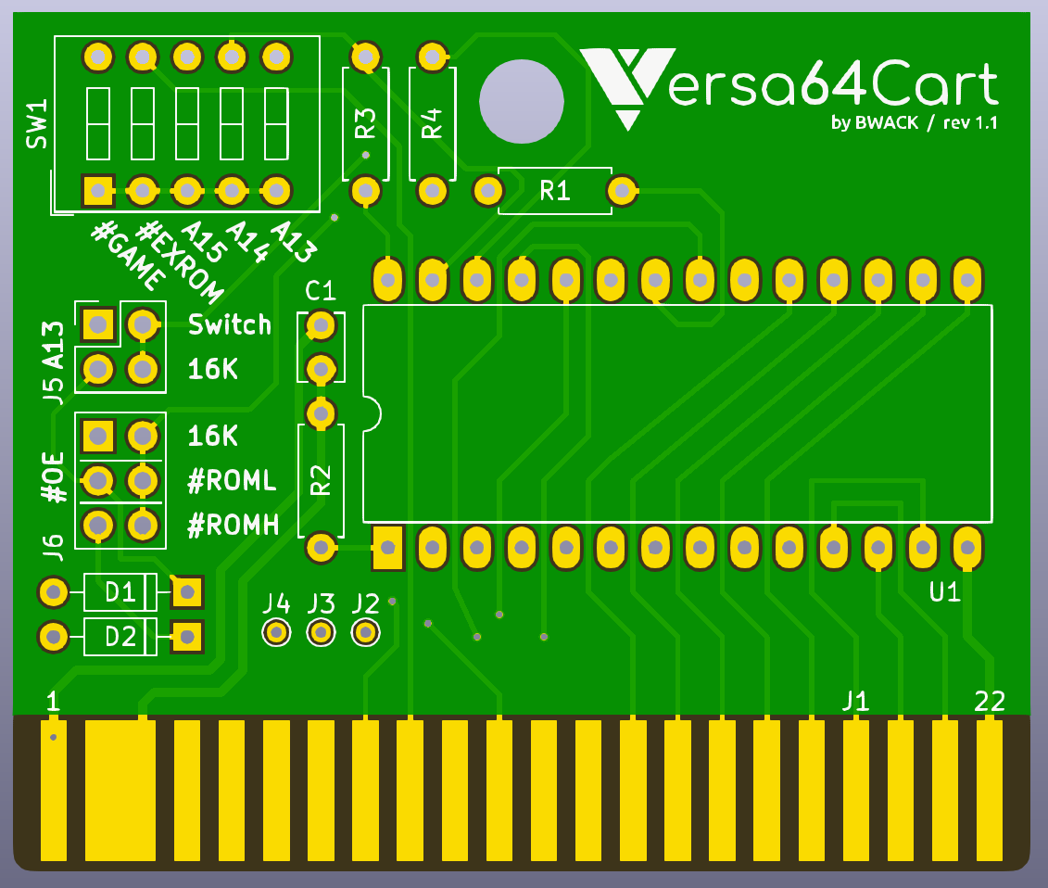
Versa64Cart is designed to be a modern easy-to-use cartridge development board for Commodore 64 and Commodore 128 hobbyists and hackers. The versatile design of the PCB allows for flexible implementation of various cartridge types. Whether it’s a simple cartridge backup of an 8k game or a
switchable multi-program diagnostic cartridge, Versa64Cart has you covered.

Overview

- Supported EPROMS:
27C64 (8k), 27C128 (16k), 27C256 (32k), 27C512 (64k)
- Ability to access multiple program images by using optional on-board DIP switches(*)
- Rapid low-cost production of clean, single image cartridges via simple solder pad bridging option
- PCB designed to fit inside any standard C64 cartridge shell, including centre post versions
- Rounded corners to allow for easier cartridge insertion and reduced wear to PCB

(*) CAUTION: Only make DIP switch changes when computer is power off. Never change DIP switch settings while cartridge is inserted and computer is powered on.

The board

Jumpers and DIP switches
Bank control

The dipswitch controls EPROM_ A13
in 8k mode.
The computer controls EPROM_A13
in 16k mode
#ROML & #ROMH are mixed
by D1 and D2 in 16k mode
because two chipselects
has to become one
ROMs with start address $8000
ROMs with start address $E000
test points: CPU A15, A14, A13

Technical note: The Versa64Cart makes it possible to run 2x8k (16k) ROM games on a single 16k EPROM device. Two chipselects has to become one, and the two 8k images has to be banked with A13.

Banking is easy! We let the computer control EPROM_A13. A jumper is put on J5:16k. The jumper now disconnects DIP switch A13 and reconnects #ROML to EPROM_A13. We have banking! The two chipselects are #ROMH and #ROML and are mixed with D1 and D2. A jumper on J6:16k routes the mixed signal to the EPROM_#OE.

Instead of #ROML on EPROM_A13 we could have used CPU_A13. It would have a better timing, because #ROML is a product of A13 from the PLA, but would it work in ultimax mode? In ultimax mode the two 8k banks are not placed adjacent ($8000-9FFF and $E000-$FFFF).

Solder Jumpers
You don't need to attach jumpers and DIP switches if you just want a single game or a dead test cart. You can use solder jumpers instead.
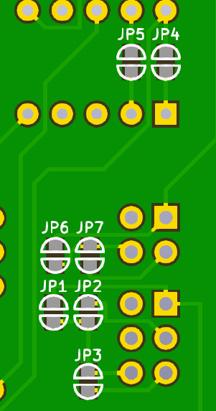
solder jumper settings | #EXROM | #GAME | switch | 16K | 16K | #ROML | #ROMH
mode | JP5 | JP4 | JP6 | JP7 | JP1 | JP2 | JP3
8k | x |  | x |  |  | x
8k ultimax |  | x | x |  |  |  | x
16k | x | x |  | x | x
16k ultimax |  | x |  | x | x

The ROM image

Setting #GAME and #EXROM
Mapping the EPROM into memory is done with the #EXROM and #GAME jumpers. There are 4 modes:

8k: #EXROM=0, #GAME=1 : start $8000-$9FFF #ROML
8k ultimax: #EXROM=1, #GAME=0 : start $E000-$FFFF #ROMH
16k: #EXROM=0, #GAME=0 : start $8000-$9FFF (#ROML) + $A000-$BFFF (#ROMH)
16k ultimax: #EXROM=1, #GAME=0 : start $8000-$9FFF (#ROML) + $E000-$FFFF (#ROMH)

You can find the mode of a .CRT file using WinVICE's cartconv.exe.

C:\WinVICE-2.4-x86>cartconv -f Wizard_of_Wor.crt
CRT Version: 1.0
Name: Wizard of Wor
Hardware ID: 0 (Generic Cartridge)
Mode: exrom: 0 game: 0 (16k Game)

offset sig type bank start size chunklen
$000040 CHIP ROM #000 $8000 $4000 $4010
Finding the mode for Wizard of Wor in a CRT file.

#EXROM and #GAME are routed to the PLA and the PLA is the address decoder inside the C64. The PLA controls and drives the ROML and ROMH signals used to put the EPROM onto the data bus.

Converting .CRT to .BIN
The EPROM must be programmed with a binary file. Use WinVICE's cartconv.exe tool to convert the .CRT file.

C:\WinVICE-2.4-x86>cartconv -i Wizard_of_Wor.crt -o wizardofwor.bin
Input file : Wizard_of_Wor.crt
Output file : wizardofwor.bin
Conversion from Generic Cartridge .crt to binary format successful.
Converting CRT to BIN for burning to EPROM.

Examples

Dead Test Cart example
You must program a 27C64 EPROM with the dead test image. The Dead Test cartridge is in 8k ultimax mode (Please see "Setting #GAME and #EXROM"), and effectively replaces the C64 Kernel ROM. Solder in the programmed EPROM, and put a solder blob on JP4, JP6, and JP3 to configure as shown in the table above. Solder in the four 22k resistors. Solder in a 100nF cap on C1.
Note: If you use 27C128/256/512, and you have burned the 8k image in the beginning of the EPROM, you must connect A15, A14 and A13 to GND on SW1. You can do that by soldering three wires from top to bottom of SW1 where the silkscreen says A15 A14 and A13.

Multi-Cart example
An example with 16k + 8k + 8k ROM images on a 27C256 (32k) EPROM.

Jumpan Junior: 16k, #EXROM=0, #GAME=0, start=$8000
Dead Test: 8k ultimax, #EXROM=1, #GAME=0, start=$E000 (#ROMH)
Jupiter Lander: Same as Dead Test. Usually it is not ultimax though.

memory area | ROM image | DIP switches & jumpers
$0000-$1FFF | Jumpan Junior | ↑↑x↑x, J5:16k, J6:16k
$2000-$3FFF | Jumpan Junior | ↑↑x↑x, J5:16k, J6:16k
$4000-$5FFF | Dead Test | ↑↓x↓↑, J5:Switch, J6:#ROMH
$6000-$7FFF | Jupiter Lander | ↑↓x↓↓, J5:Switch, J6:#ROMH
DIP switch positions: ↑=0V, ↓=5V, x=don't care

Solder in the programmed EPROM, the DIP switches, the 2x2 and 2x3 2.56mm pinheader, two 1n4148 on D1 and D2, the four 22k resistors, and a 100nF cap on C1. Use jumpers on J5 and J6.

This is the same example I have used in my Versa64Cart YouTube video. Now you should write down the settings because you will forget them. A 27C512 ROM will give you twice as much space. Eight 8k games, four 16k games or a mix of this.

Other notes
Kernal ROMs on the cartridge does not work.

Board Manufacturing
The board thickness is 1.6mm. The board is 58.0 x 48.9 mm. PCB prototyping houses take gerber files. Some companies can handle .kicad_pcb files directly. Creating gerbers is beyond the scope of this document, however I have made a video about it on my YouTube Channel:
- KiCAD Gerber files and DirtyPCBs

Enclosures
The board is based on original cartridges and enclosures. The board width is 58mm. It fits original cartridge enclosures and Jim Brain's ones too. It does not fit stumpy cart. The standoffs are 1mm narrower. That can be tweeked. You can't use a ic-socket because then the eprom hits the top.

Aknowledgements
I would first of all like to thank MindFlare Retro for helping me out with this document. Also a thank you to Jim Brain for the Simple64Cart and its eagle design files. MindFlare converted the eagle .brd file to kicad. I took the cartridge outline (document layer) and imported it in my own design. From there it was super easy to design on top of that drawing. Also a big thanks to my viewers on YouTube for feedback on this project.

PCBnew Screenshot
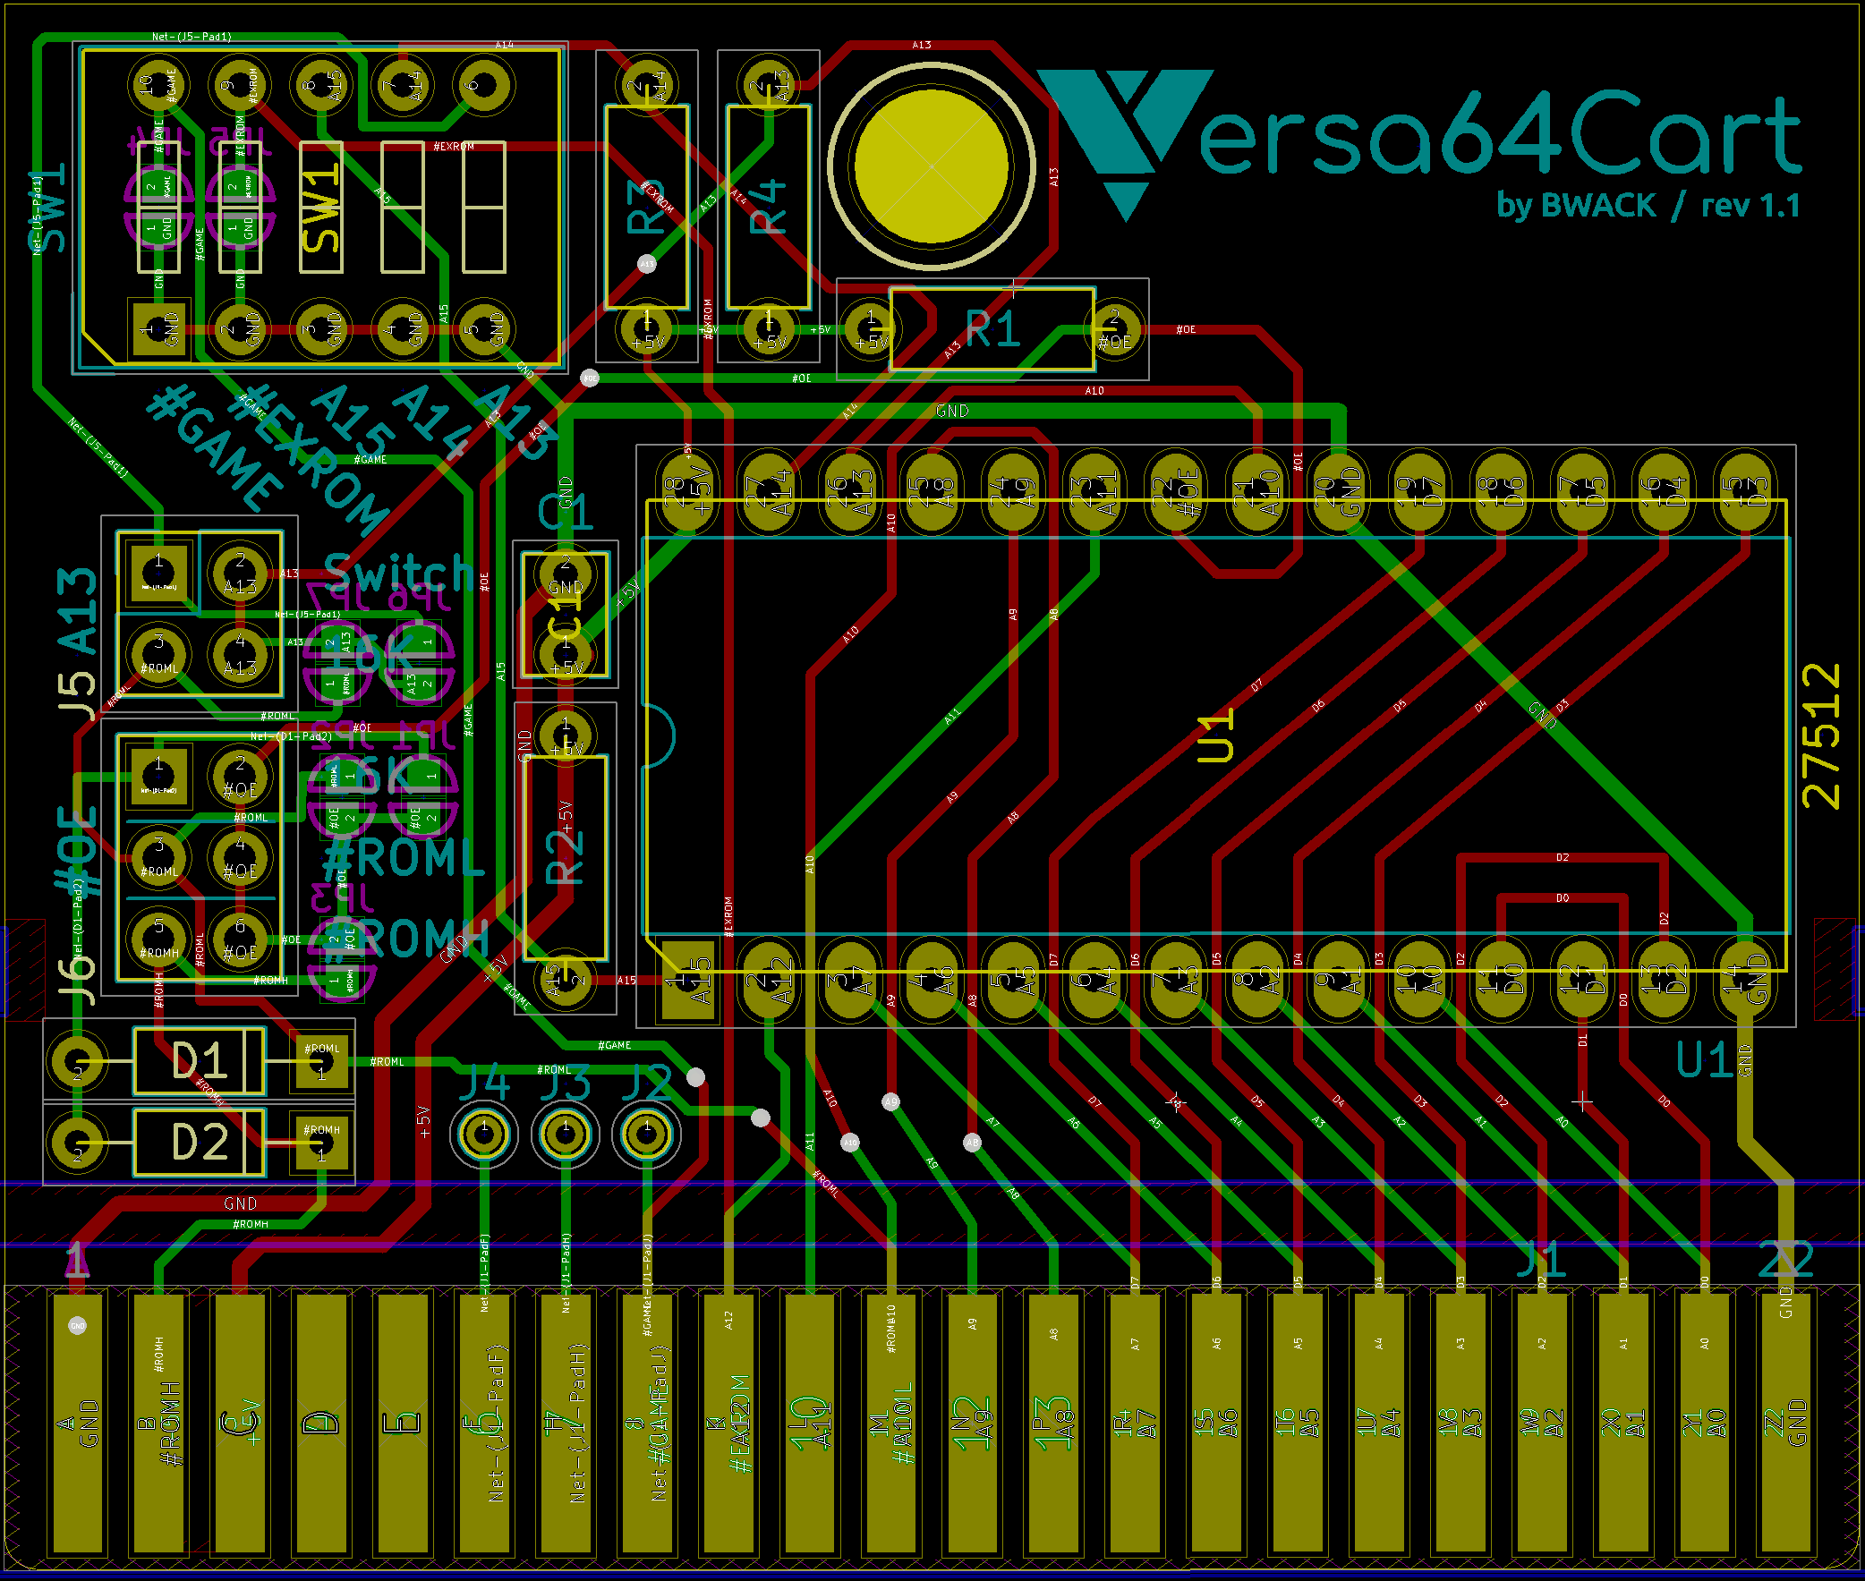
Zoom on the PDF to see the signal names on the traces.

Schematics
